|  |  |  |  |  |  |  |  |  |
| --- | --- | --- | --- | --- | --- | --- | --- | --- |
| |  | | --- | | Benro Video Tripod - A673TMBS8 Pro | | Product image thumb |  |  |  |  |  | | --- | --- | --- | --- | | Product image thumb | Product image thumb | Product image thumb |  | |  | **Specifications:**  Weight: 5.45kg  Dimensions: 997 x 247 x 241mm  Structural materials: Aluminum and Magnesium  Maximum height: 1585mm  Minimum height: 750mm  Load capacity: 8kg  **Price: 470$** |

**Overview:**

**Benro Video Tripod - A673TMBS8 Pro**

Benro Video Tripod - A673TMBS8 Pro is designed specifically for professional videographers and photographers. The tripod is made of aluminum in the form of a double tube, making the tripod extremely sturdy and can withstand a load of up to 8kg, but the weight of the Benro Video - A673TMBS8 Pro tripod is only 5.45kg. Benro Video Tripod - A673TMBS8 Pro is divided into 3 segments with maximum height up to 1585mm, minimum height 750mm. The bottom of the tripod is covered with rubber so it can stand firmly on any surface.

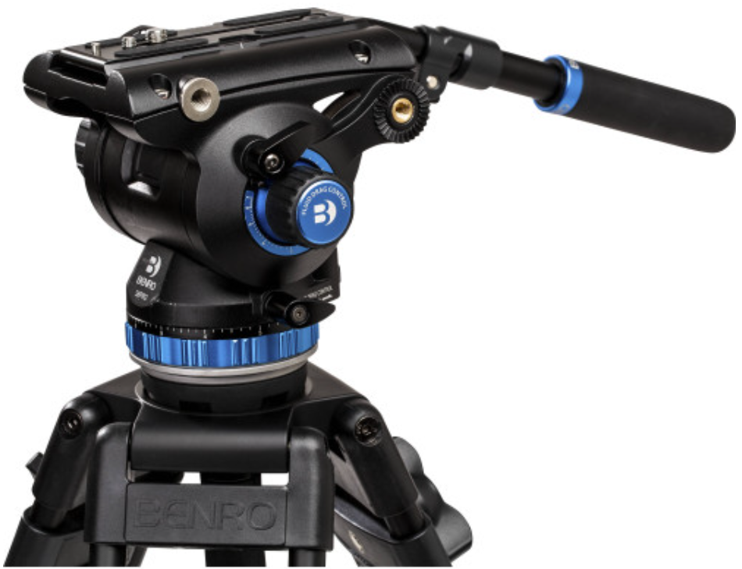

The S8Pro ball head is made from extremely sturdy aluminum and magnesium so you can safely place a camera or camcorder weighing up to 8kg without having to worry about safety. In addition, the S8Pro ball head of the tripod has a safety locking slide and can rotate 360 degrees and tilt at a 90 degree angle to help users be creative with their shooting scenes.

